Assembly of the BB3+ chassis
To make following the enclosure assembly steps easier, the descriptions will also include part labels in parentheses next to the name of each component, as shown in the table that follows.

For assembly, you will need a PH1 screwdriver (for screws), a 5.5 mm HEX driver (for nuts) and a 10 mm HEX driver (for knob).

Parts used in the assembly of the enclosure
Part label | Part image/picture | TME part number | Description | Note
1 | 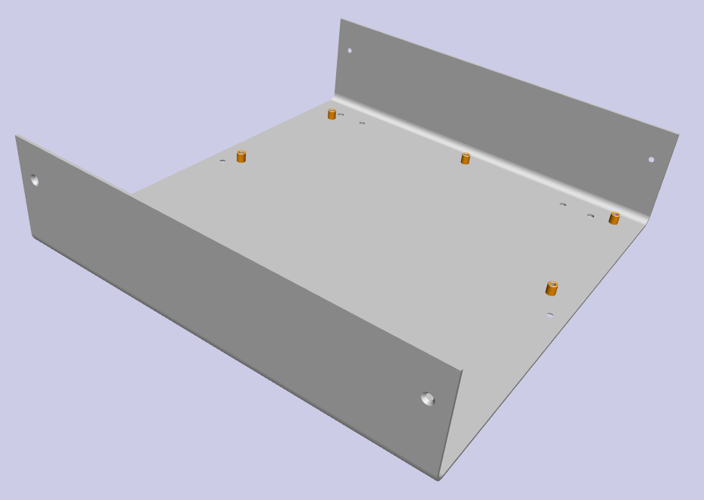 | n/a | BB3+ enclosure bottom plate (3D model)
2 | 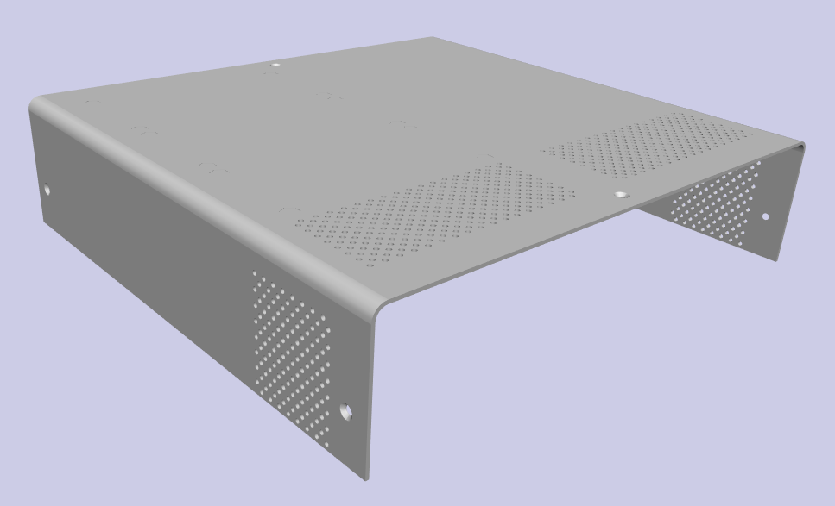 | n/a | BB3+ enclosure top cover (3D model)
3 | 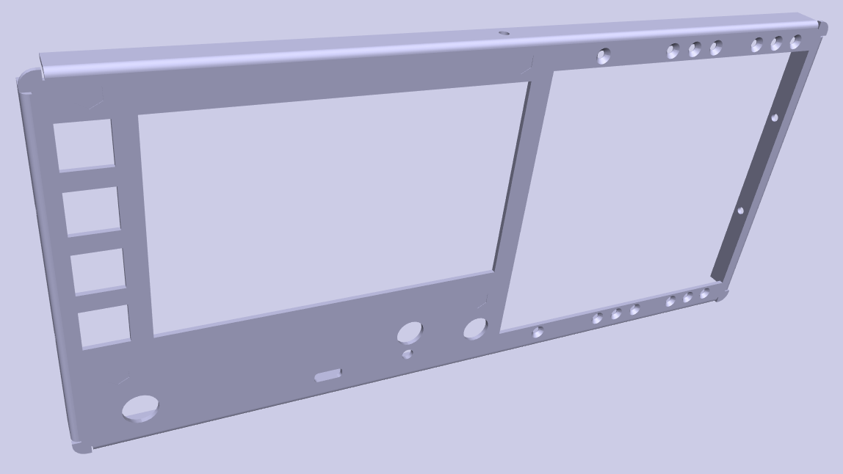 | n/a | BB3+ enclosure front panel (3D model)
4 | 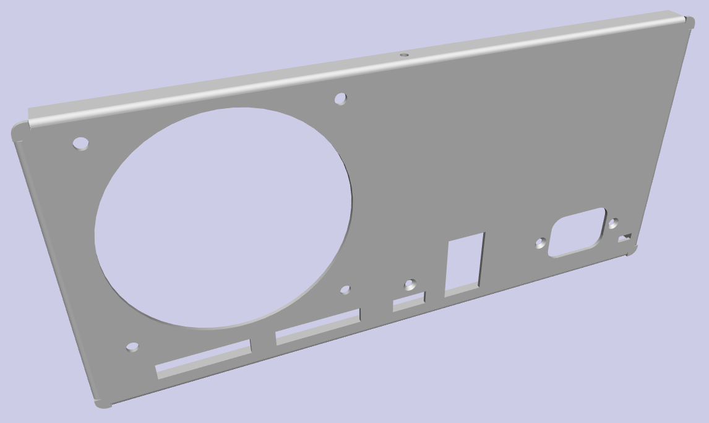 | n/a | BB3+ enclosure rear panel (3D model)
5 | 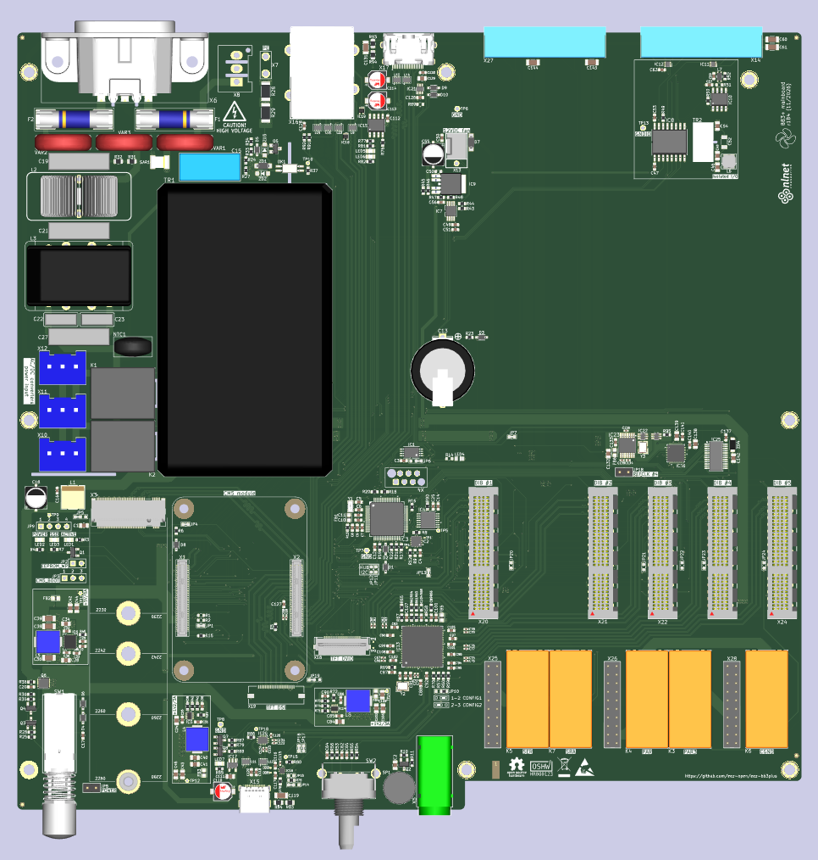 | n/a | BB3+ mainboard (3D model)
6 | 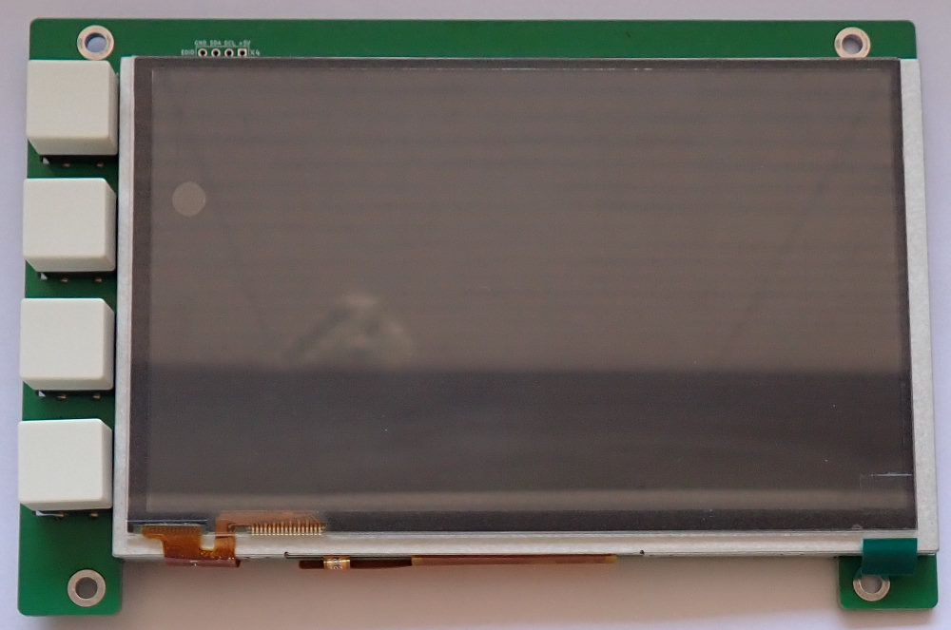 | n/a | BB3+ TFT module | The module must have a TFT touchscreen display bonded to the PCB using double-sided adhesive tape, prior to mounting onto the front panel.
7 | 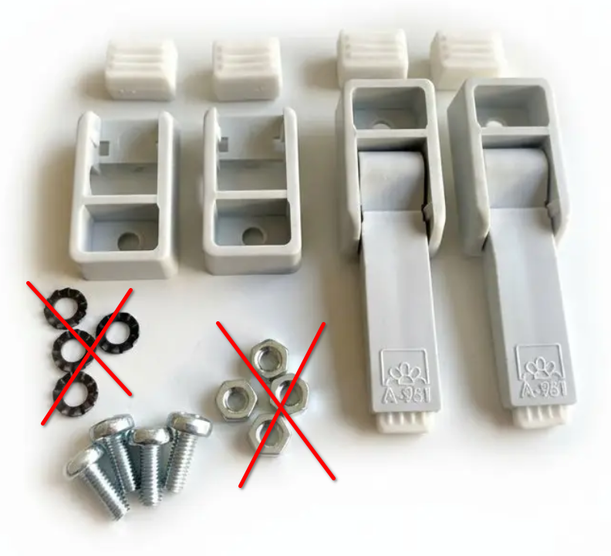 | n/a | A-951-A-0-S-0, Tilt plastic foot set; color: black (grey shown on picture)  (Vendor: Altynkaya, Türkiye) | The crossed-out elements in the picture will not be used, as the bottom plate has M4-threaded mounting holes.
8 | 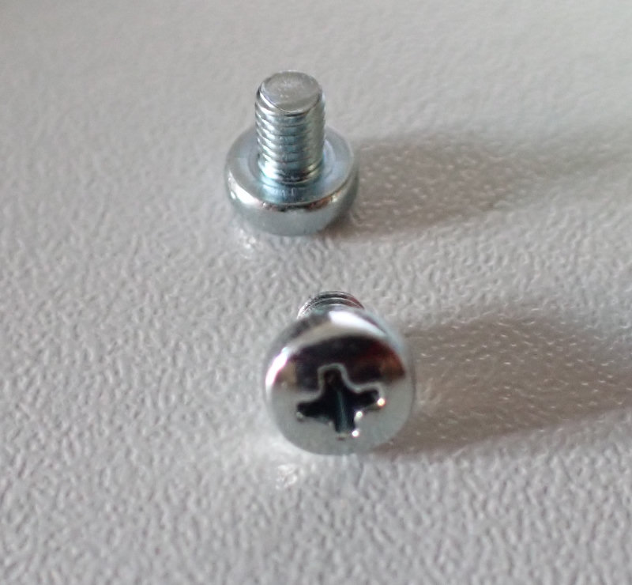 | M3X4/D7985 | Screw; M3; M3x4; 0.5; Head: cheese head; Phillips; PH1; DIN 7985; Zinc plated | An equivalent part from another manufacturer may be used.
9 | 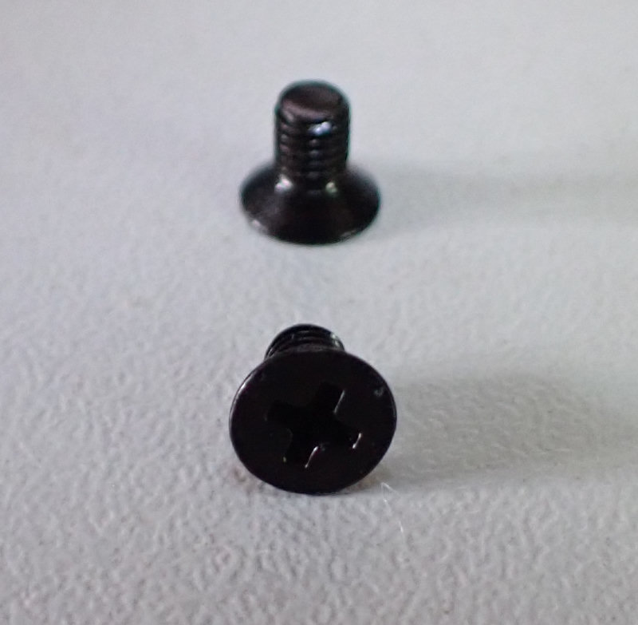 | M3X5/D965B | Screw; M3; M3x5; 0.5; Head: countersunk; Phillips; PH1; steel; Black finish | An equivalent part from another manufacturer may be used.
10 | 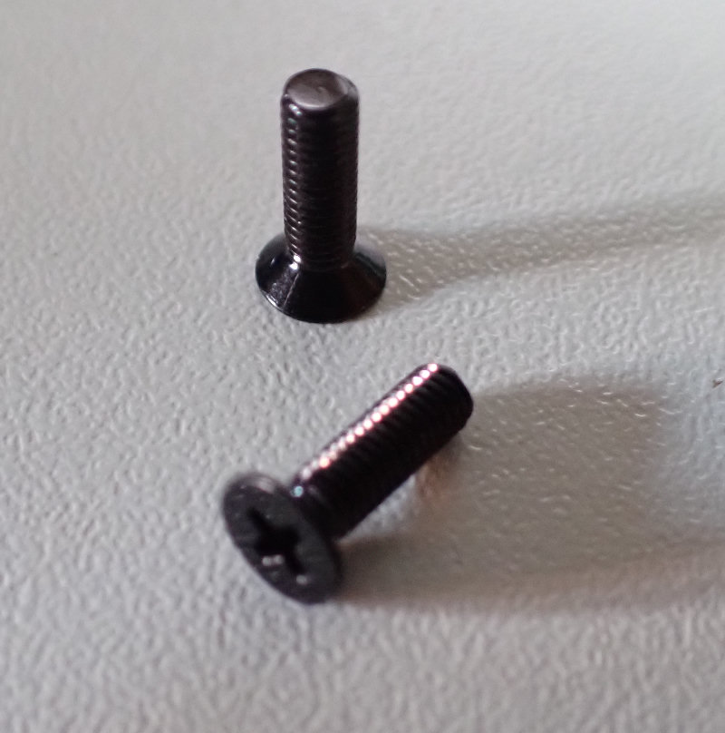 | M3X8/D965B | Screw; M3; M3x8; 0.5; Head: countersunk; Phillips; PH1; steel; Black finish | An equivalent part from another manufacturer may be used.
11 | 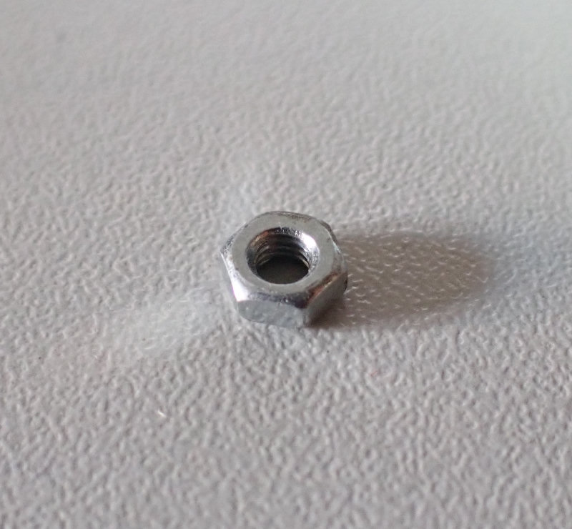 | B3/BN117 | Nut; hexagonal; M3; 0.5; steel; zinc; H: 2.4 mm; 5.5 mm; BN 117; DIN 934; Zinc plated | An equivalent part from another manufacturer may be used.
12 | 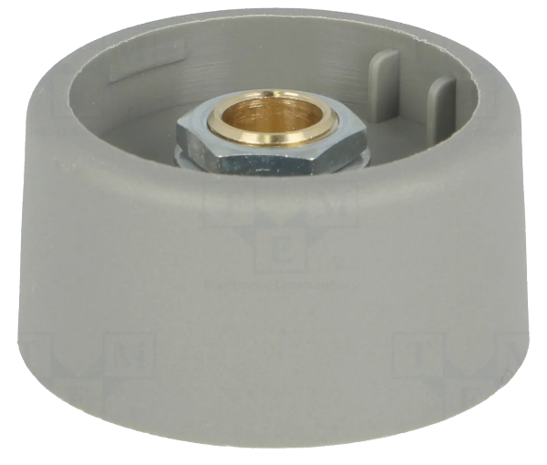 | A3131068 | Knob; without pointer; polyamide; Øshaft: 6 mm; Ø31x16 mm; grey | See the BB3+ Mainboard BOM
13 | 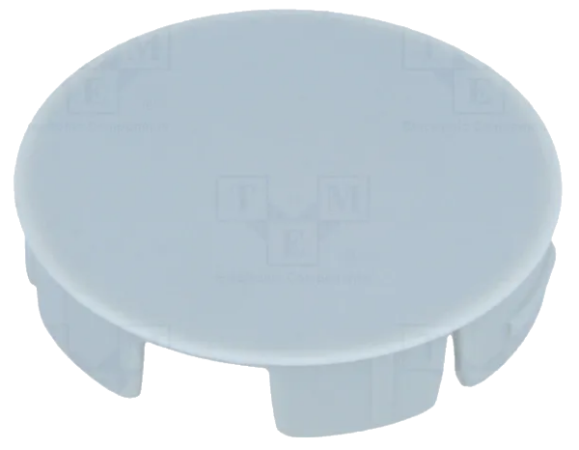 | A3231007 | Cap; polyamide; grey; push-in | See the BB3+ Mainboard BOM
14 | 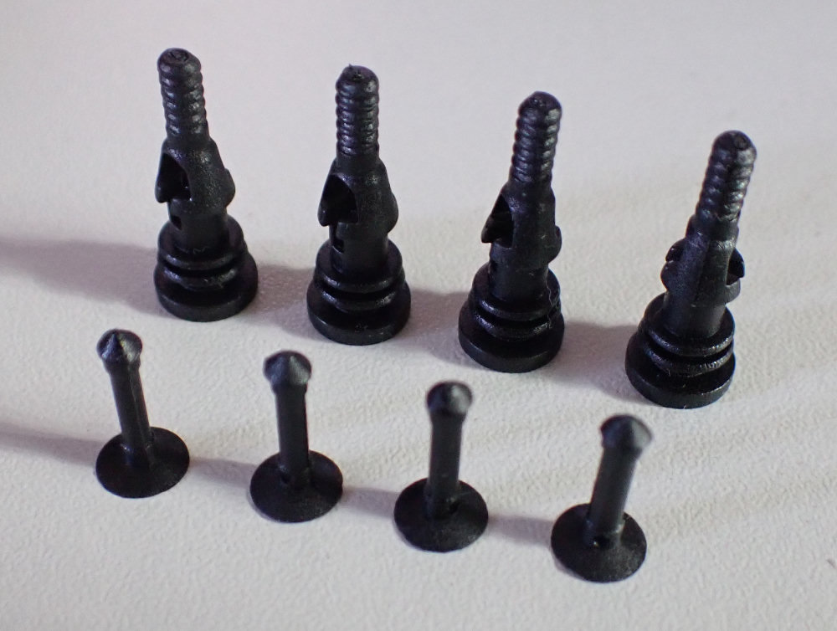 | FSP-2 | Fastener for fans and protections; plastic; black; 4.5 mm | Parts from other vendors may also be used, provided they are compatible with the Sunon MF92251V1-G99-A 12 Vdc fan (see the BB3+ Mainboard BOM for details on the fan and finger guard).
15 | 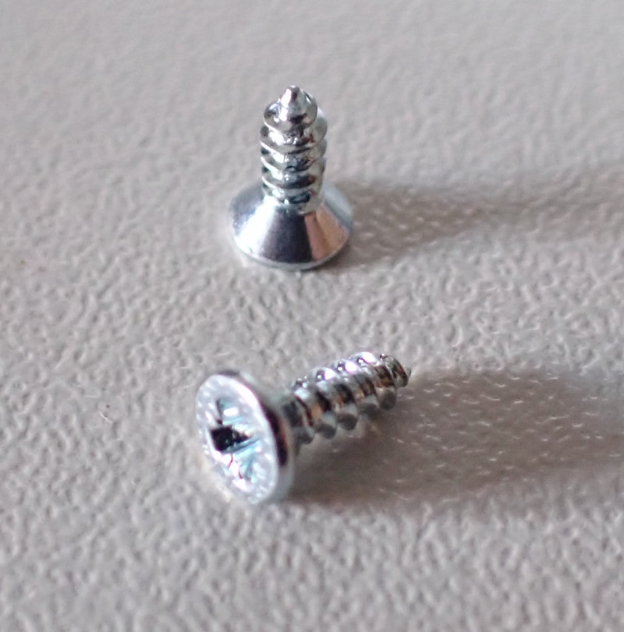 | B2.2X6.5/BN995 | Screw; 2.2x6.5; Head: countersunk; Phillips; PH1; steel; zinc | An equivalent from another manufacturer may be used.
16 | 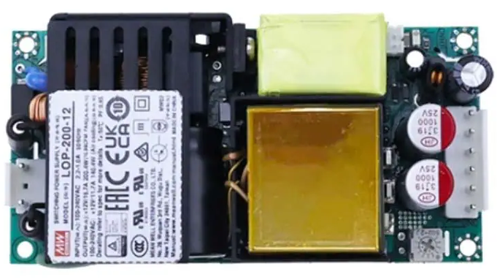 | EPP-150-48 or LOP-200-48 | 4" × 2" Low Proﬁle Open Frame Power Supply, 48 V, 155 or 200 W | See the DCP405+ BOM
17 | 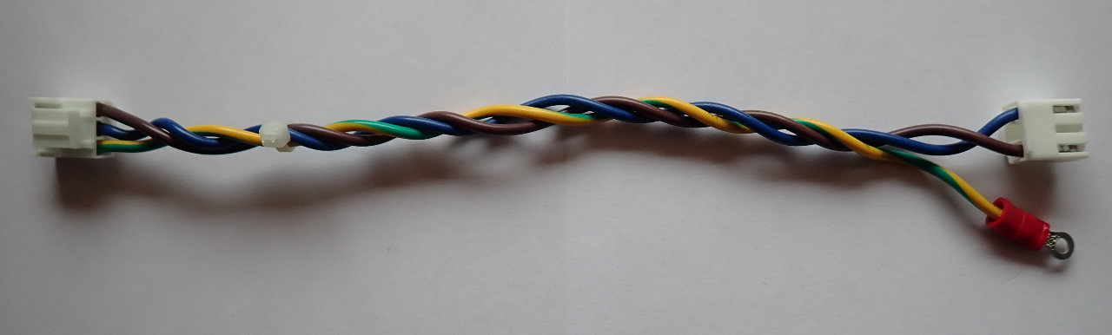 | n/a | AC power module cable | See the DCP405+ Wire harness
18 | 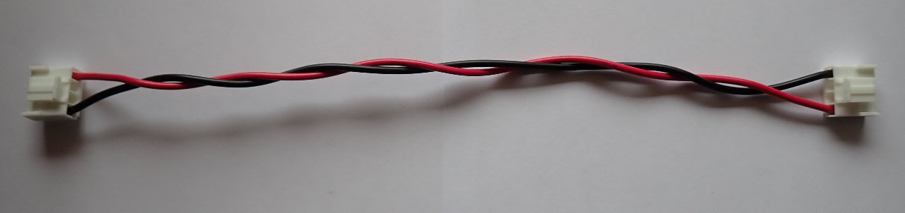 | n/a | DC power module cable | See the DCP405+ Wire harness
19 |  | n/a | Half width front panel mask (3D model)
20 |  | n/a | Full width front panel mask (3D model)

Step-by-step assembly instructions

- Identify the front side of the bottom plate (1). The position of the corner metal spacers will help you in this. Those located towards the front side are positioned under the holes for mounting the plastic feet as shown on image below:

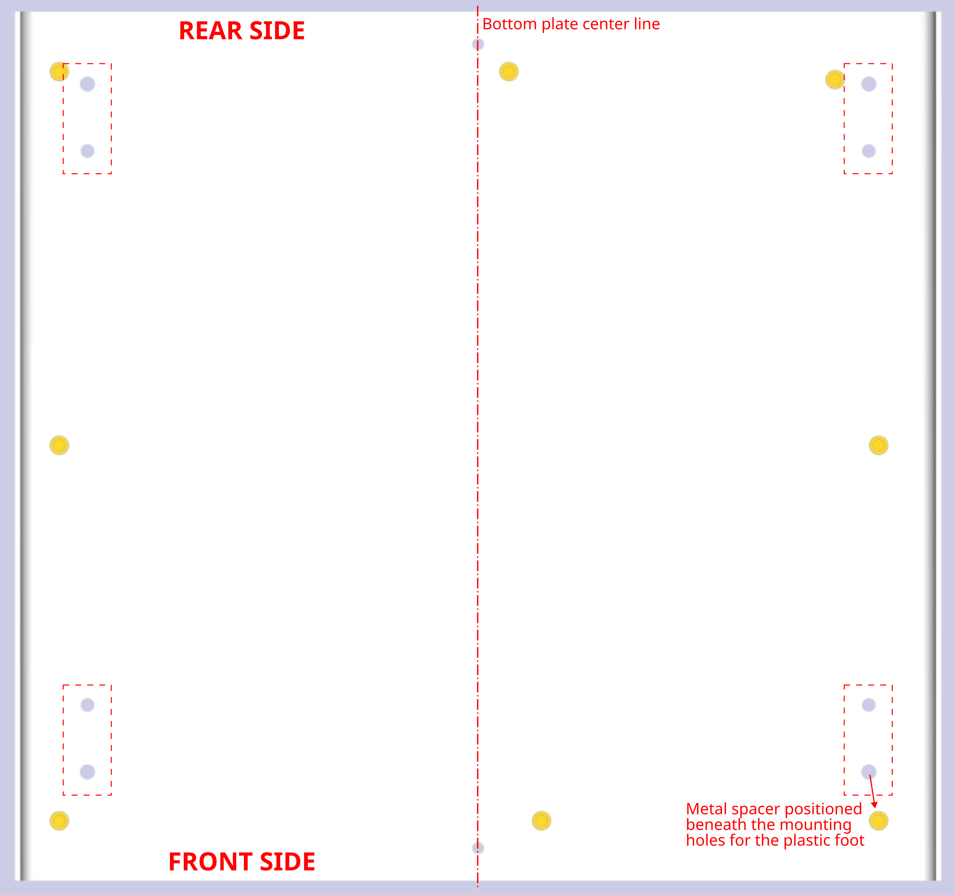

- Attach the plastic feet (7) to the bottom plate (1). The set of plastic feet includes two tiltable feet, which are mounted at the front, and two non-tiltable feet, which are mounted at the rear. Use the M4 screws included in the set. Once the plastic parts of the foot are attached to the bottom plate, the rubber parts can be inserted, thereby covering the screw heads.
- Now the mainboard (5) can be mounted on the bottom plate. For this, use 8 screws (8), which you will screw into all 8 metal spacers on the bottom plate.
- The next step is attaching the front panel to the bottom plate. However, before that, it will be necessary to mount the TFT module. The TFT module is mounted from the rear side of the front panel using four screws (8), as shown in the picture below. Before the front panel is fixed on the bottom plate, make sure that the 22-pin FFC cable is connected to the side of the TFT module (DVID Input).

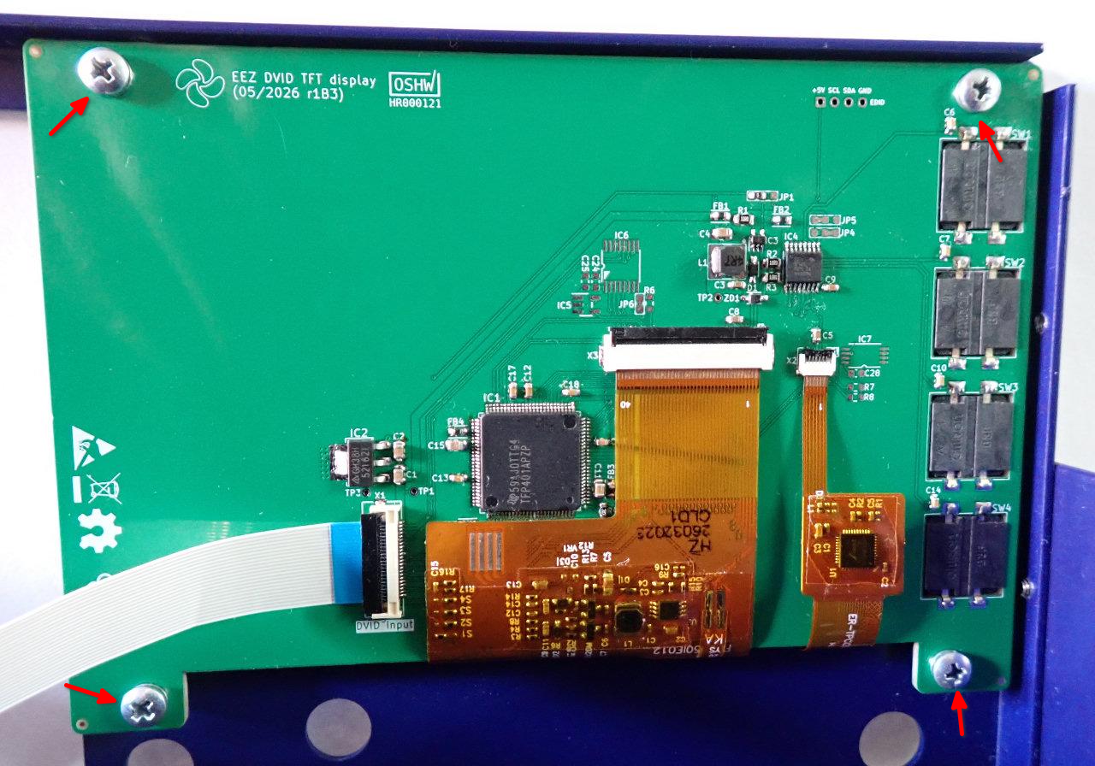
- Attach the front panel, with the TFT module mounted on it, to the bottom plate using three countersunk screws (9): one on each side, and one in the middle of the bottom plate.

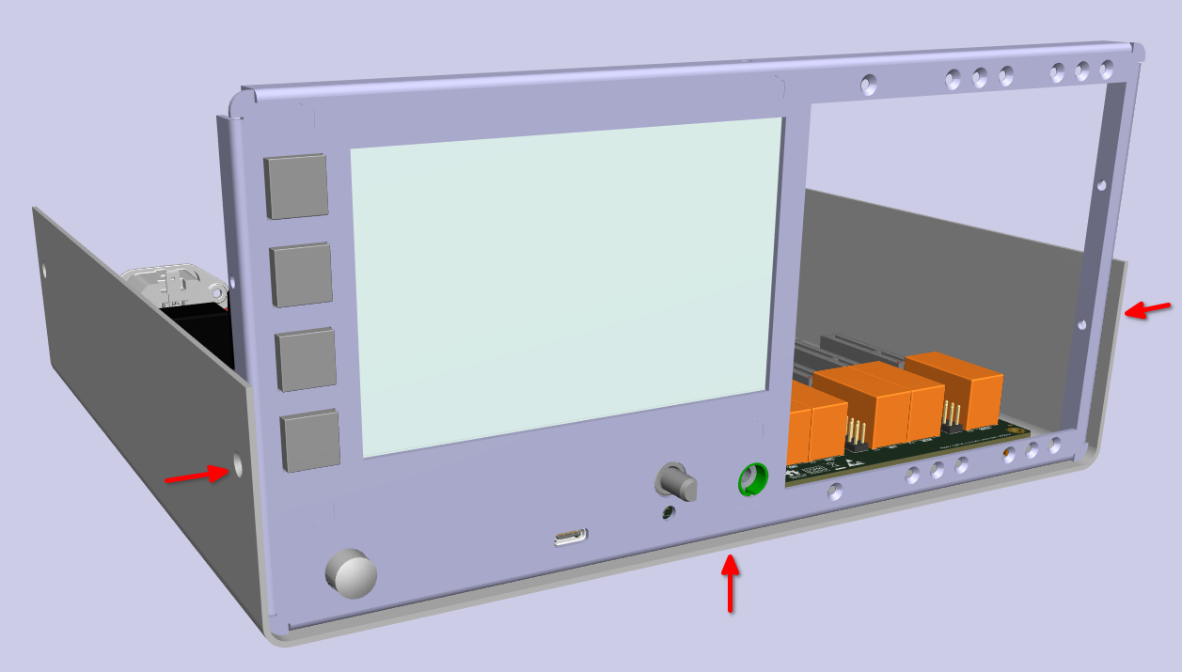
- Mount the knob (12) onto the encoder shaft using a 10 mm HEX driver. Once tightened onto the shaft, the knob should be positioned far enough away from the front panel to allow the integrated push-button to function when pressed. This distance should be between 0.5 and 0.8 mm. When the knob is well monitored and the button is functional, the push-in knob cap (13) can be put on by carefully pressing it.
- Next up is the rear panel. Before fixing it to the bottom plate, a few preparatory steps will also need to be taken. The first is the installation of the fan. The fan is installed on the inner side of the rear panel; to do this, rubber spacers (14) must first be placed into the designated holes. Once the fan is secured using the plastic fasteners (14), a finger guard must be attached to the outer side. The picture below shows what the fan looks like when mounted on the rear panel.

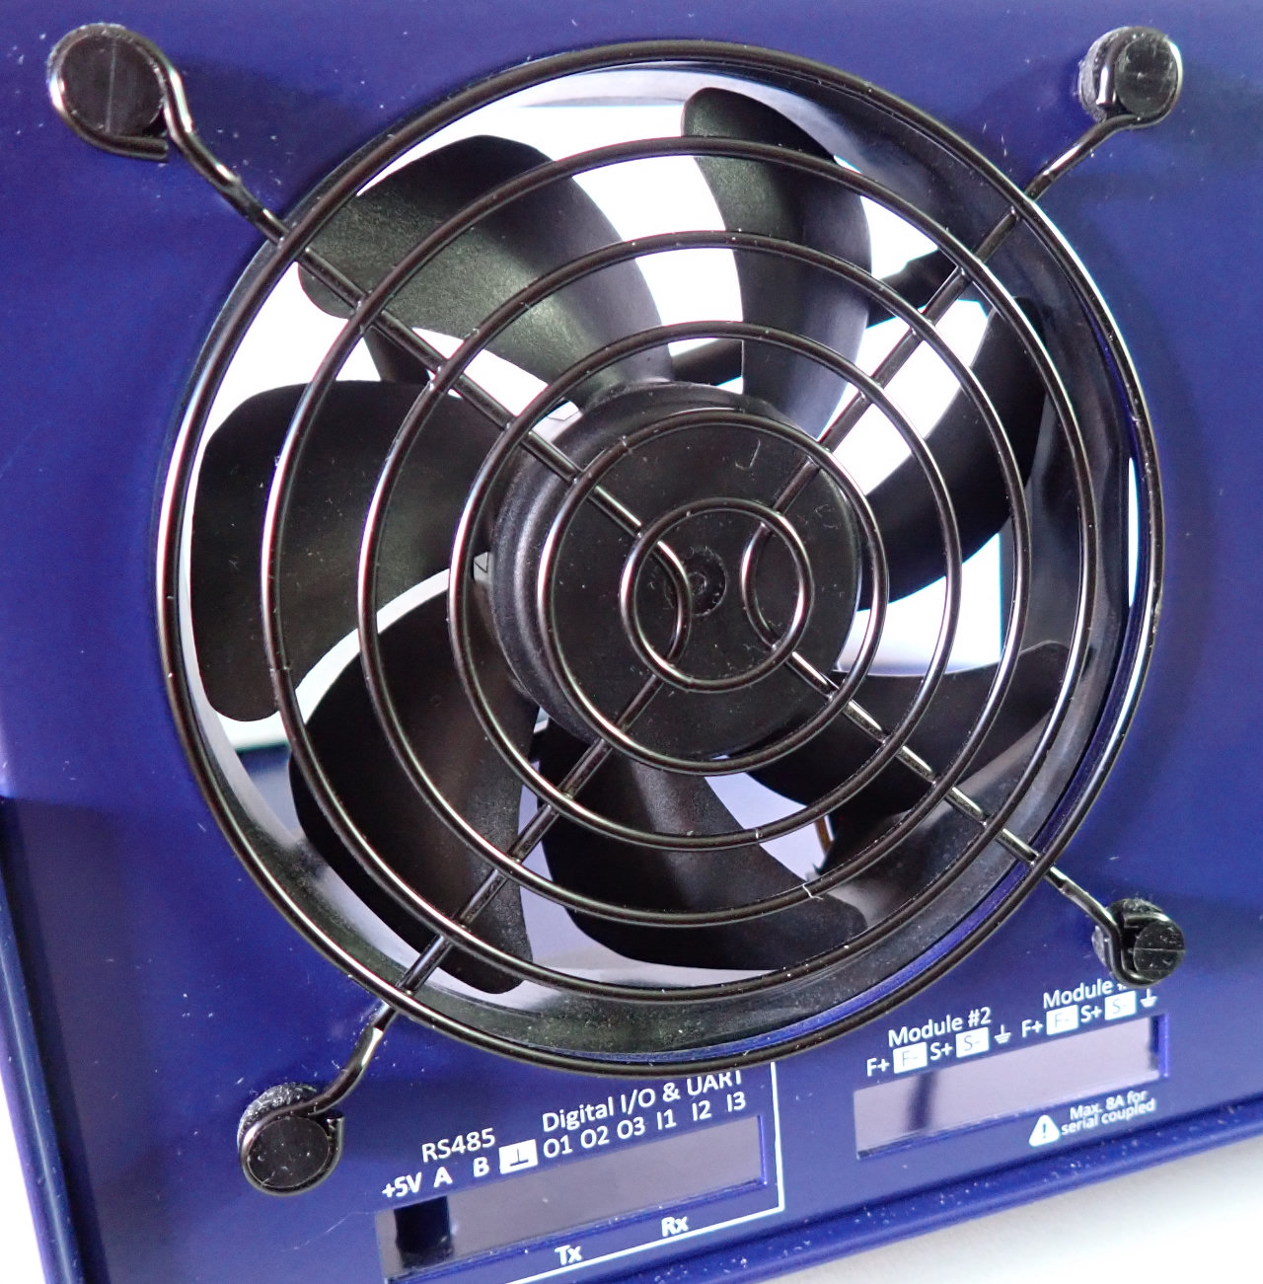
- The rear panel can now be carefully inserted onto the back of the unit, ensuring that all connectors exposed at the rear fit into their corresponding openings. Once this is done, and before securing the rear panel to the bottom plate, it is advisable to fasten the DVID Out connector using one countersunk screw (9). Next, secure the AC inlet using two countersunk screws (10) and their corresponding nuts (11), holding the nuts in place with a 5.5 mm HEX driver.

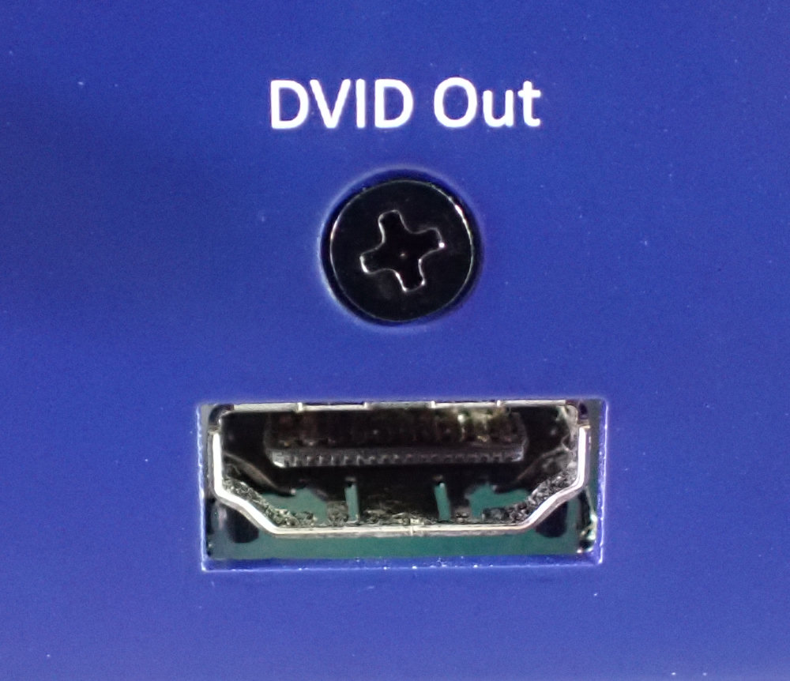 | 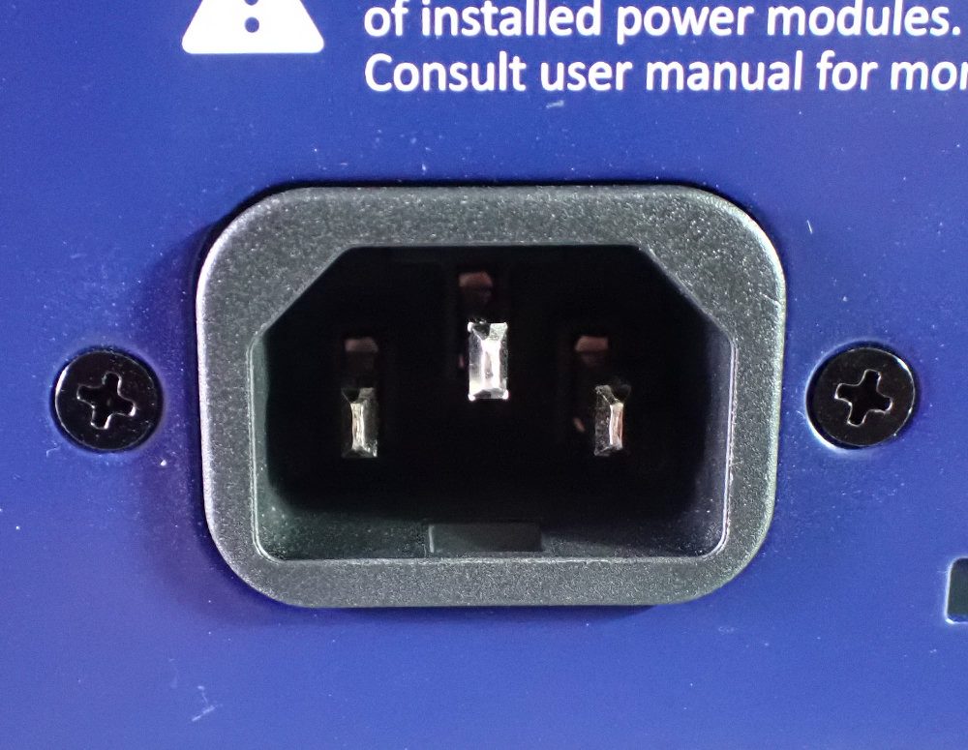

- Now secure the rear panel using three countersunk screws (9), just as you did with the front panel. Next, plug the 3-pin fan connector into the corresponding connector on the motherboard (see the image below).

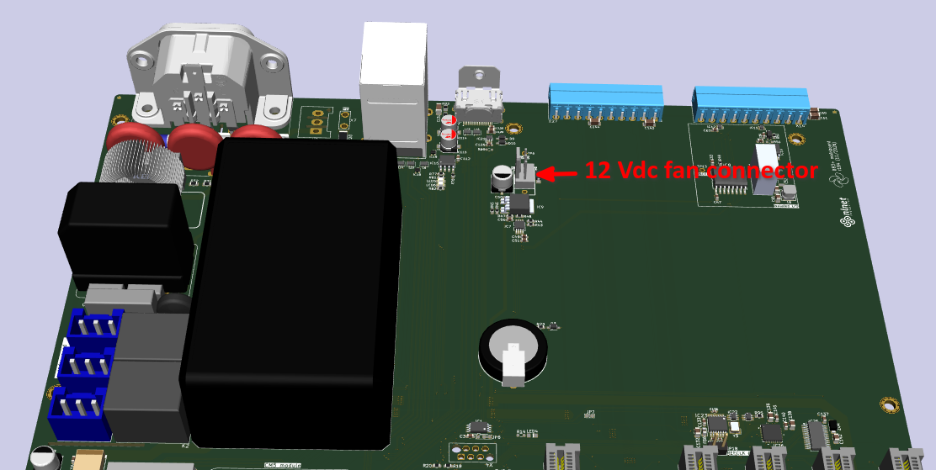
- Depending on the configuration of the BB3+ chassis, one or more peripheral modules can now be installed. Power modules such as the DCP405+ can only be mounted in slots #1, #2, and #4. Once the module has been carefully inserted into the slot on the mainboard, it should be secured with two countersunk screws (15).
IMPORTANT: These are self-tapping screws; when driving them in for the first time, you will need to apply a bit more force to cut the threads into the PCB of the module's front panel. Take care to avoid any damage or visible scratches that could occur if the screwdriver slips.

The picture below indicates the locations for the screws used to attach the module to the enclosure's front panel.
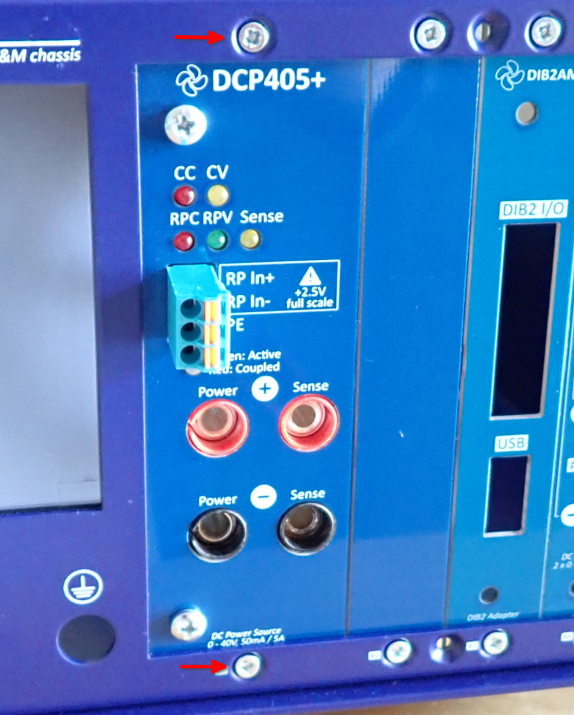

- Power modules require additional wiring and installation of AC/DC modules (16) on the top cover of the enclosure (2), where there are places for mounting up to 3 AC/DC modules. Mount the AC/DC module (16) using four screws (8), as shown in the picture below, ensuring that the AC input connector is positioned closer to the edge of the top cover. Connect cables (17) and (18) to each of the modules.

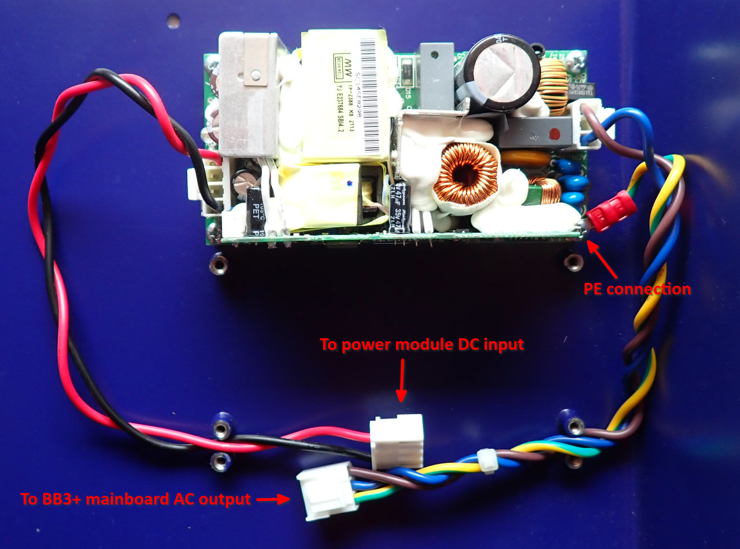
- After the AC/DC modules for the selected configuration are mounted on the top cover, they should be connected to the BB3+ mainboard and power modules. For this, it is perhaps best to place the top cover behind the enclosure as shown in the image below.
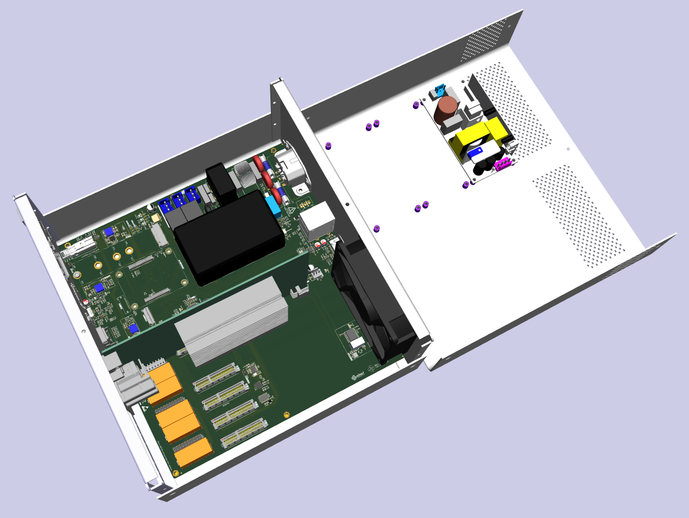
- The DC power cable (18) should be connected to the power module connector whose position is shown in the image below.

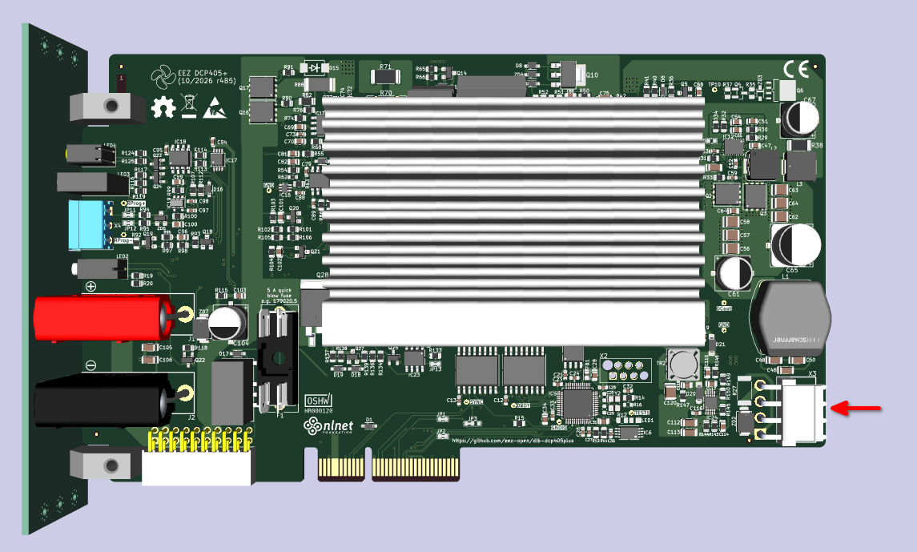
- The AC power cable (17) should be connected to one of the connectors on the mainboard.
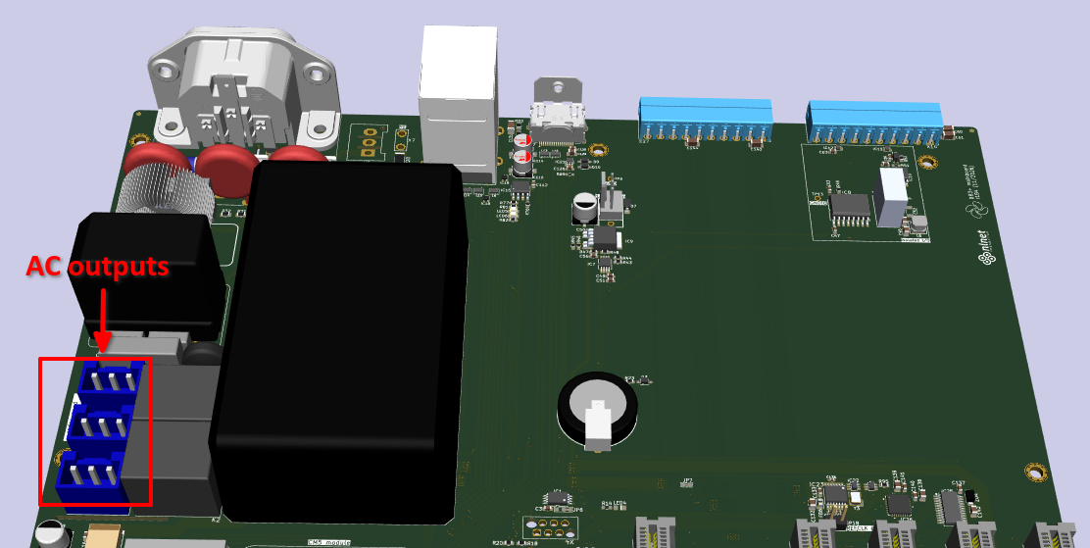
- Openings on the front panel where no modules are installed must be covered with one or more front panel masks. Half-width (19) and full-width (20) bare front masks are used, and their number will vary depending on the configuration:

SKU | Model | Description | Slot #1 | Slot #2 | Slot #3 | Slot #4 | Slot #5
2027001 | BB3+ single DCP | BB3+ chassis with DCP405+ module installed in slot #1 | DCP405+ | Full width mask |  | Half width mask | Half width mask
2027002 | BB3+ dual DCP | BB3+ chassis with two DCP405+ module installed in slot #1 and #2 | DCP405+ | DCP405+ |  | Half width mask | Half width mask

- The final step is attaching the top cover to the front and rear panels of the enclosure. For this, 6 countersunk screws (8) are used, the positions of which are shown in the two following images (view from the left and from the right):

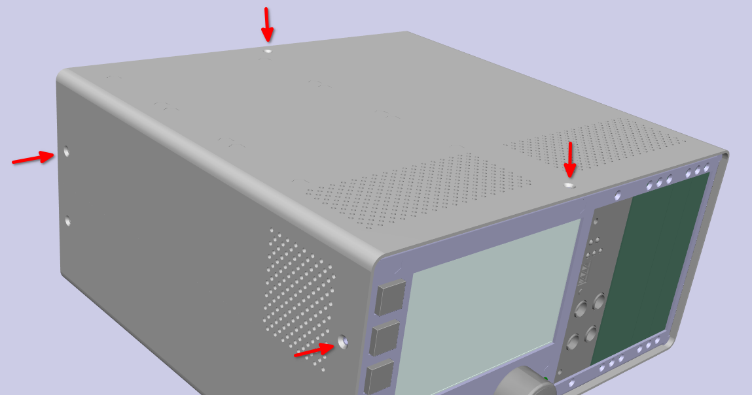

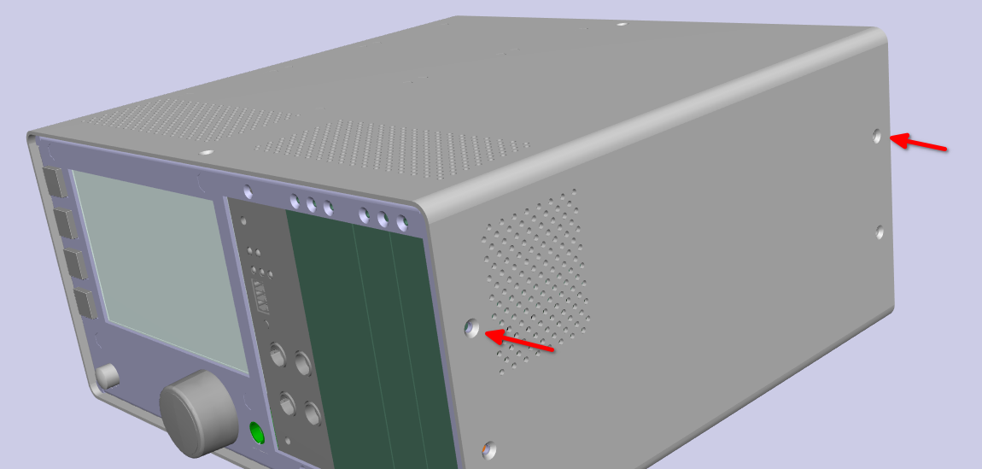
IMPORTANT: as shown in the inages, the perforated sections of the top cover must face the front of the enclosure.

